Use-Case Realization Report (Analysis)
Update Question

Issue 1.0
Revision History
Date | Issue | Description | Author
01/Aug/09 | 1.0 | First Issue | Thomas Yap

Table of Contents
1. Brief Description 4
2. Flow of Events 4
3. Interaction Diagrams 4
3.1 Collaboration Diagram for Update Question 4
4. Participating Objects 4
5. Class Diagrams 5
5.1 Class Diagram for Update Question 5
6. Derived Requirements 5

Use-Case Realization Report
Update Question

Brief Description
This use case enables the controller to add new questions to Question Pool. It involves displaying the menu and form. It involves displaying the menu and form and search by searchstrings or list to update the record.

Flow of Events
The standard flow of events for this use case and any exceptions are described in the following subsections. The events are described in terms of Actors and Analysis Objects.

Standard Flow
This use case covers the Question Maintenance - Update Question. The standard flow of these events are described below.

Update Question
The running of the application is shown in section 3.1. The flow of event is as follow:

- When the application start, the first operation to be performed is the startup operation of the main controller. This operation will create all the control objects and the entity objects necessary for operation Update Question:
  - The control object created is: Question Controller
  - The entity objects create are: Question and Transaction Record

- The main controller will start the main function menu:
  - To start Update Question, operation FormDisplayQuestion is activated by Question Controller to display a Question form.
  - Operation validate will validate the format of the entries.
  - Then Question Controller will check for additional criteria if any.
  - If no record found, QuestionController will send a error message to FormDisplayQuestion Interface.
  - After the record is found and display on FormDisplayQuestion, Portal Admin is to change any details in the form. A confirmation request will be sent to the FormDisplayQuestion interface. Upon confirmation, the record will then be updated to file using operation update to entity object Question.
  - In addition, a transaction log will be created by operation insertQuestionRecord
  - A confirmation message will be displayed by FormAddQuestion interface.

- Step 2 will be repeated until all updates are completed. Then controller will terminate the application by issuing operation close.

Exception
None.

Interaction Diagrams

Collaboration Diagram for Update Question
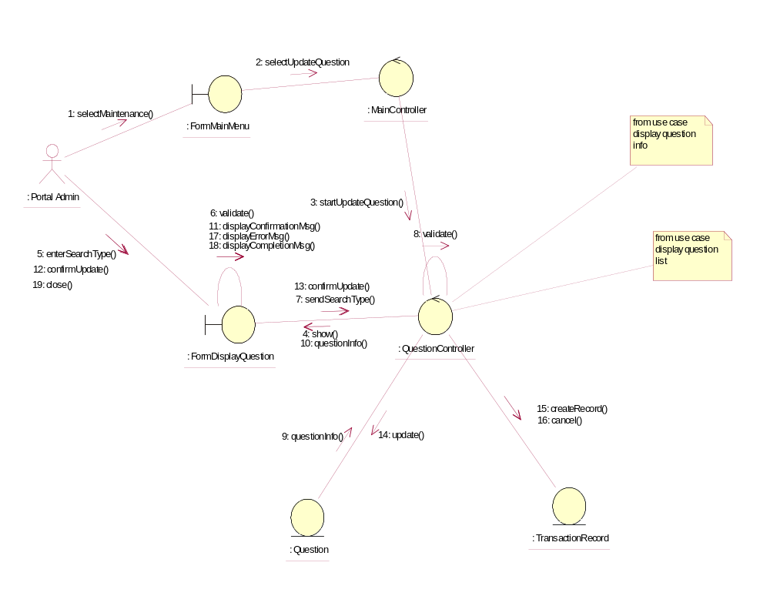

Participating Objects
: FormDisplayQuestion
This object is the interface for keying questions details.

: FormMainMenu
This is the main menu at the beginning of the application from where it can access the Question Maintenance - Update Question operation.

: MainController
This is the main controller that control the whole system.

: Portal Admin
This is the only actor that authorized to perform operation Question Maintenance - Update Question.

: Question
This entity stores all the exam or exercise questions.

: QuestionController
This is the controller for Question Maintenance. It creates and activates FormDisplayQuestion interface and Question entity object.

: TransactionRecord
This is the entity object that created for transaction log and audit trail.

Class Diagrams

Class Diagram for Update Question
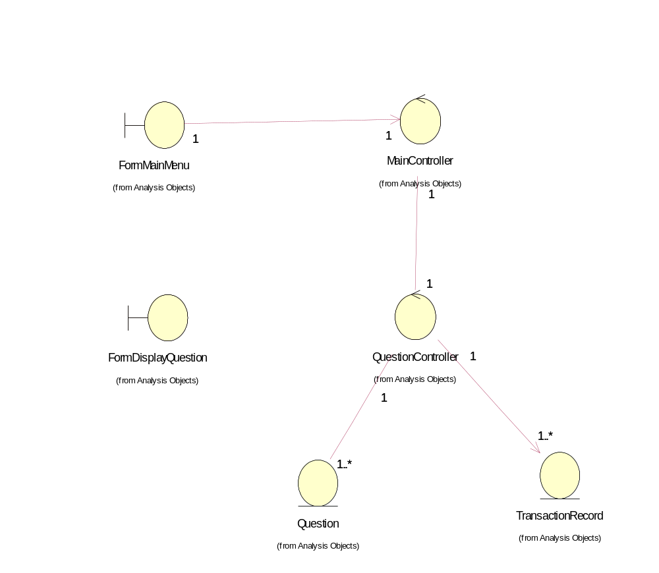

Derived Requirements
The FormMainMenu and FormDisplayQuestion Interface should have the format specified in User Requirements Specification for Content Management Portal.

